E-RATION SHOP

A report submitted for the course of
Application development-1
II B. Tech II Semester

by

2011CS030034: K.Sandeep Kumar
2011CS030084: K.Anurag Teja
2011CS030076: T.Jonathan Abhishek Rao

Under the esteemed guidance of

Dr.K.Srikanth
(Associate Professor)



Department of Computer Science & Engineering (Data Science)
Malla Reddy University
Maisammaguda, Dulapally,
Hyderabad, Telangana 500100
www.mallareddyuniversity.ac.in
2021-22


CERTIFICATE

This is to certify that this is the bonafide record of the application development entitled “E-Ration Shop”, submitted by 2011CS030034: K.Sandeep Kumar, 2011CS030076: T.Jonathan Abhishek Rao, 2011CS030084: K.Anurag Teja, of B. Tech II year II semester, Department of CSE (Data Science) during the year 2021-22. The results embodied in this report have not been submitted to any other university or institute for the award of any degree or diploma.

Internal Guide APP DEVELOPMENT CONVENER Head of the Department
K.Srikanth Dr.P.Anitha Dr.GS Naveen Kumar
Associate Professor CSE (Data Science) CSE (Data Science)

Table of Contents
ABSTRACT 4
LIST OF FIGURES 5
LIST OF ABBREVIATIONS 6
1.1 Problem Statement 7
1.2 Objective 7
1.3 Scope 7
1.4 Applications 8
2. Literature Survey 8
3. DEPENDENCIES USED 10
3.1 Software Requirements 10
3.2 Hardware Requirements 10
4. DESIGN AND IMPLEMENTATION 11
4.2 Implementation 13
Login Page 14
1. Customer Login 14
2. Delivery 16
3. Government Administrator 17
4. Ration Supplier 20
CONCLUSION 22
REFERENCES 22

ABSTRACT

The Public Distribution System (PDS) is an Indian food security system. It is established by the Government of India under the Ministry of Consumer Affairs, Food, and Public Distribution and managed jointly with state governments in India. The traditional PDS is used to distribute grocery items to India’s poor who are valid ration card holders. The validity and the allocation of the ration cards are monitored by the state governments. A ration card holder should be given 35 kg of food grain as per the norms of PDS. However, there are concerns about the efficiency of the distribution process. To make it efficient and improve the current system of PDS, we are implementing an e-Ration Shop. Here we are going to make a website for shopping purposes. Using this website ration card holders can order their grocery items from the FPS online.

E-Ration shop is a Government-backed entity which sells ration products online. It mainly focuses on providing rations at the availers’ doorstep without much hassle along with proper and transparent stock keeping as the goods are directly shipped from godowns to the customers’ doorstep. The fear of being cheated by the ration shop owners’ malpractices is completely eradicated. At the moment there is no online system being implemented to further supervise the process of monthly rations and without an online solution the customers face the problem of waiting in long queues, bargaining and some non-suspecting rationers being cheated by the shop owner. Implementing an online shop system would greatly benefit the Government as well as the customer by maintaining full transparency of the items available and their quantities. One of the many perks of implementing this system would be the online payment feature which would allow the customer to pay through one of the many available paths and the payment along with the items purchased would be stored in a database without the intervention of any person to avoid any false transactions and later be accessed by the Government administrator.

The crux of this application is to provide an alternative to the age-old method of walking a long distance to the ration shop only to wait in line for hours, provide complete transparency in the products being sold to the customers to maintain proper stock management as well as provide job opportunities to delivery agents. This application is easy to use, malpractice free and can be accessed at any time of the month without any human participation in the ration shop.

LIST OF FIGURES

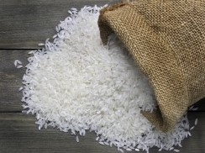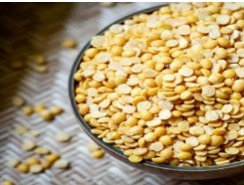

Fig.1

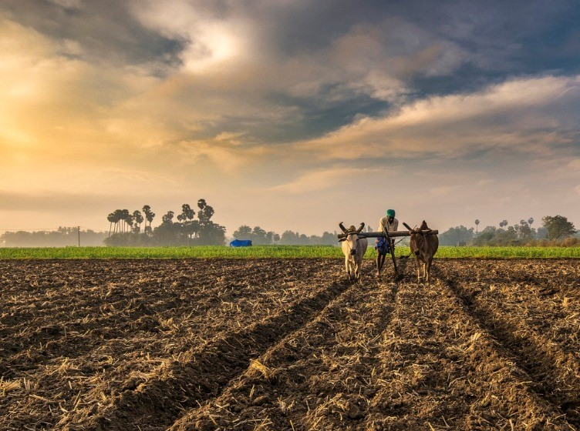

Fig.2 Fig.3

LIST OF ABBREVIATIONS

- HTML: Hyper Text Markup Language

- CSS: Cascading Styles

- SQL: Structured Query Language

- PDS: Public Distribution System

- FPS: Fair Price Shop

CHAPTER 1

1. Introduction

In developing countries like India, the plan of subsidising basic domestic commodities for poor families is an important part of meeting people’s basic needs. When a self-contained system for ration distribution is available, it benefits cardholders in a variety of ways. The E-Ration is the most convenient way to purchase ration items. Its goal is to offer ration products on the internet.

E-Ration Shop is an automated system that distributes the exact amount of ration to cardholders based on the type of ration card and the number of family members, as well as keeping track of transactions in a database. As a result, this approach will reduce dealer communication, manual calculations, and time spent in stores.

The cardholder can access the rationing system at any time during the month, with no need for human participation in the ration shop. Each transaction is automatically logged into the database by this system. Customers who purchase ration items online will have their information saved in an internet database, which will be viewable to higher-ranking officers as well as the shop owner. A fair price store (FPS) or ration shop is another name for a public distribution shop. It is a part of the Government of India's public distribution system, which provides subsidised rations to the needy in India. The Civil Supplies Corporation is a key government agency that oversees and distributes basic supplies to all inhabitants.

Various products like rice, sugar, and kerosene are supplied utilising a traditional ration store method in that system. Some of the drawbacks of the traditional ration shop system include: The user is unable to obtain an accurate quantity of material due to laborious measurements in the traditional technique. Because it is a direct process done by an online ration shopkeeper, this application uploads the data immediately to the server, confirming the data. Because it is a direct process done by the online ration shopkeeper, they cannot do anything in these transactions as they do in paperwork.

Problem Statement

To make the ration shop system efficient and improve the current system of PDS, we are implementing an e-Ration Shop. Here we are going to make a website for shopping purposes. It can be monitored and controlled remotely and greatly reduces the manpower required and provides accurate information.

Objective

- To design the user module that allows people to order, view available stock and view the price of each commodity without any difficulty.

- To design the administrator module that allows the administrator to add, edit and view the commodities and also their prices.

- To check that the modules work taking into consideration efficiency, time and memory.

Scope

- To remove corruption in the present PDS system.

- People can order commodities from anywhere.

- Greater user usability and generation of continuous income.

1.4 Applications

- Reduces manpower.

- Reduces bogus card usage.

- Reduces time consumption.

- View the status of an order.

CHAPTER 2

2. Literature Survey

Online grocery delivery has been a game-changer for people living in India. With expensive travel, it’s much more convenient to have your favourite groceries delivered straight from their source! You can order just one or two items at a time if needed – no need to make several trips like before when there were only physical stores around town that accepted all denominations of currency. The convenience is what makes this such an attractive option among consumers here; they’re able to get anything they want without having any hassle whatsoever which means less money spent on food expenses each week as well as happier shoppers too because let’s face it: nobody wants wastefully going out every day with nothing but regrets left behind.

Amazon Fresh

Amazon Fresh is a kind of online grocery store. It used to be an add-on service, but Amazon Prime members now get it for free. The online supermarket sells fresh vegetables, meat, dairy, seafood, packaged meals, Whole Foods 365 items, and household goods like cleaning supplies. On Amazon Fresh, you may buy electronics, apparel, and toys. Because the UI is the same as the rest of Amazon, it’s simple to use. Simply add items to your shopping cart.

Flipkart Grocery

Flipkart, India’s largest e-commerce company, is growing in popularity for its grocery service. Because it comes from a reputable source, and because Flipkart Super Mart has incredible deals! They feature a wide range of products, from spices to cereals to dairy products, making it a one-stop shop for all of your everyday necessities. Flipkart super mart has a nice feature called “Buy Now Pay Later,” which allows selected people to buy groceries on credit and pay later. It offers guaranteed quality on all products and is quickly becoming India’s most popular grocery app.

Jiomart

In the Indian business world, Reliance is a well-known brand. JioMart, the reliance industry’s leading grocery market, must be mentioned somehow. A grocery and basics store app for Indians who want to buy food quickly online. The JioMart app is available for Android and iOS users. Download it and use it to buy groceries with a single tap. Currently, the app offers grocery delivery in practically all of India’s metro cities, including Mumbai, Bengaluru, Hyderabad, Ahmedabad, Delhi, Meerut, Agra, Thane etc. With over 200 cities covered, it is one of the most popular online grocery delivery apps in India. The app provides the finest prices and discounts on groceries and other everyday necessities.

BigBasket

It is one of India’s most popular online food stores. Bangalore and Mumbai are the company’s headquarters. There are several product categories to choose from when browsing. A buyer places an order for goods that he or she prefers. At the agreed-upon time, the requested goods are delivered to the customer’s doorstep. Furthermore, BigBasket will pay you if they are unable to fulfil the guarantee they made to you. BigBasket has started selling chopped fruits and vegetables as well as recipe mixes. During the lockdown, BigBasket generated the most revenue. The Covid-19 epidemic was fortunate for the company, as it resulted in the largest sales since its inception. The best feature they offered was ‘contactless delivery,’ in which the delivery people would drop the groceries outside the door and notify you via phone call or doorbell that the groceries had arrived.

CHAPTER 3

3. DEPENDENCIES USED

3.1 Software Requirements

- HTML

- CSS

- Java Script

- MySQL

- IDE: Visual Studio Code

- Operating System: Windows

3.2 Hardware Requirements

- Hard Disk: 120 GB.

- Monitor: 15’’ LED

- Input Devices: Keyboard, Mouse

- Ram: 4 GB.

- Any smart device that contains a Web Browser

CHAPTER 4

4. DESIGN AND IMPLEMENTATION

4.1 Design

Designed by using HTML, CSS, JavaScript and MySQL

HTML (Hyper Text Markup Language):
HTML is an acronym which stands for Hyper Text Markup Language which is used for creating web pages and web applications.
Hypertext: HyperText simply means "Text within Text." A text has a link within it, which is a hypertext. Whenever you click on a link which brings you to a new webpage, you have clicked on a hypertext. HyperText is a way to link two or more web pages (HTML documents) with each other.
Markup language: A markup language is a computer language that is used to apply layout and formatting conventions to a text document. Markup language makes the text more interactive and dynamic. It can turn text into images, tables, links, etc.
Web Page: A web page is a document which is commonly written in HTML and translated by a web browser. A web page can be identified by entering an URL. A Web page can be of the static or dynamic type. With the help of HTML only, we can create static web pages.

CSS (Cascading Style Sheets):
CSS stands for Cascading Style Sheets. It is a style sheet language which is used to describe the look and formatting of a document written in a markup language. It provides an additional feature to HTML. It is generally used with HTML to change the style of web pages and user interfaces. CSS is used along with HTML and JavaScript in most websites to create user interfaces for web applications and user interfaces for many mobile applications.

Java Script
JavaScript (js) is a lightweight object-oriented programming language which is used by several websites for scripting webpages. It is an interpreted, full-fledged programming language that enables dynamic interactivity on websites when applied to an HTML document. It was introduced in the year 1995 for adding programs to the webpages in the Netscape Navigator browser. Since then, it has been adopted by all other graphical web browsers. With JavaScript, users can build modern web applications to interact directly without reloading the page every time.
Features of JavaScript:
These are the following features of JavaScript:
- All popular web browsers support JavaScript as they provide built-in execution environments.
- JavaScript follows the syntax and structure of the C programming language. Thus, it is a structured programming language.
- JavaScript is a weakly typed language, where certain types are implicitly cast (depending on the operation).
- JavaScript is an object-oriented programming language that uses prototypes rather than using classes for inheritance.
- It is a light-weighted and interpreted language.
- It is a case-sensitive language.
- JavaScript is supportable in several operating systems including, Windows, macOS, etc.
8. It provides good control to the users over the web browsers.

4.2 Implementation

- Government Admin
  - Login
  - Manage Ration shop details
  - Manage Product Report
  - Manage Customer Report
  - Manage Supplier details
  - Manage ration shop administrator

- Ration Shop Admin
  - Login
  - Manage profile
  - Manage customer details
  - Stock management
  - Manage ration shop details
  - Manage order details
  - Ration shop Kit management
  - Manage product
  - Manage suppliers

- Delivery Team
  - Login
  - Register
  - Manage order details
  - Delivery management
  - Manage profile

- Ration Shop Admin
  - Login
  - Account details
  - View products
  - View purchased product
  - View shopping cart
  - Payment screen

CHAPTER 5

- SIMULATION RESULTS

Following are the test case results

Login Page

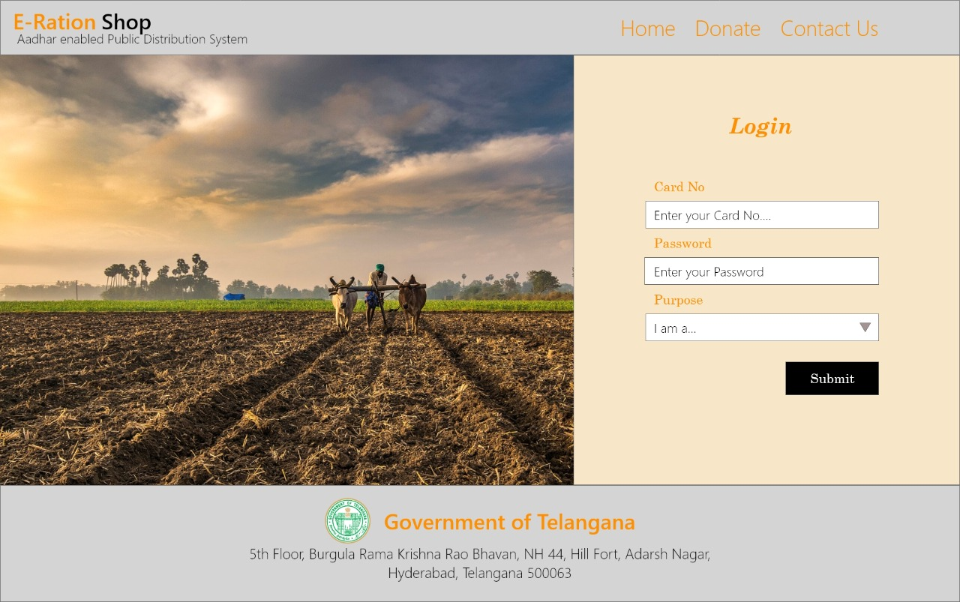

Customer Login

1.1 Ration card details
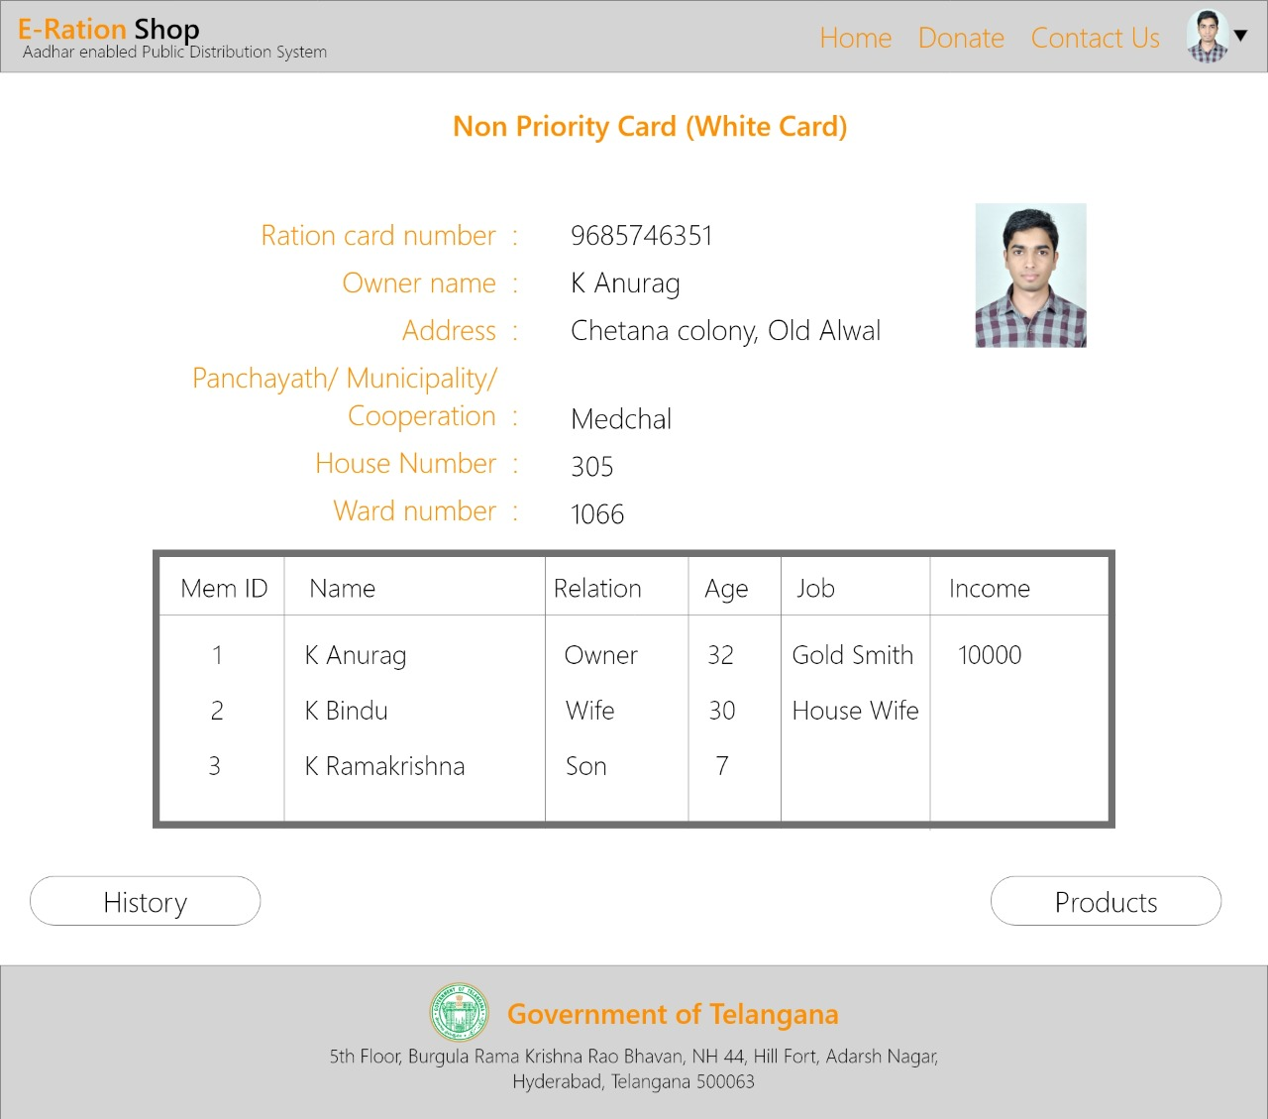

1.2 Available Products
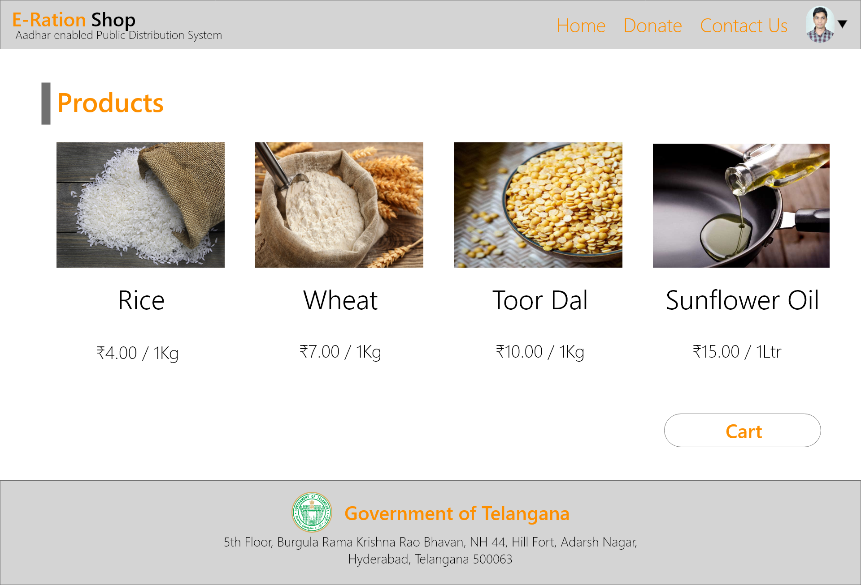

Fig 1.2

1.3 Cart Details
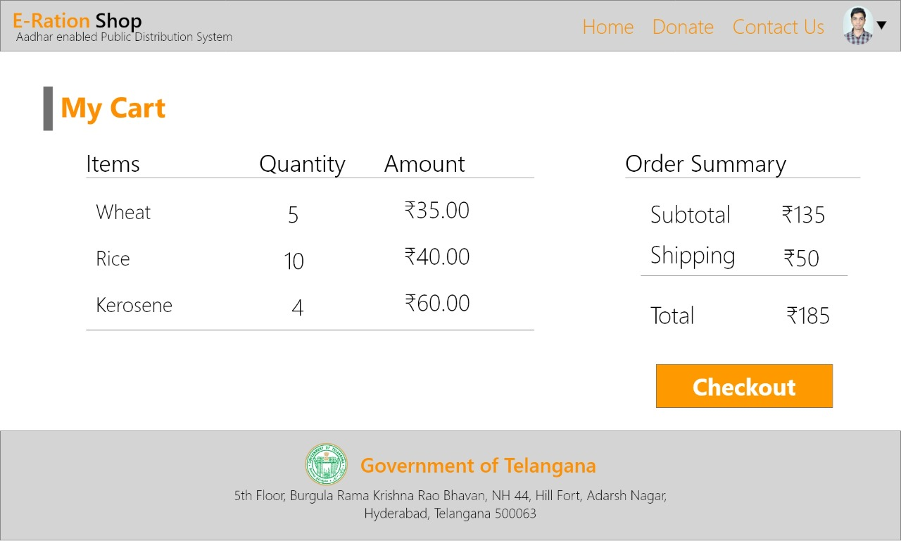

Fig 1.3

2. Delivery

2.1 Delivery Agent
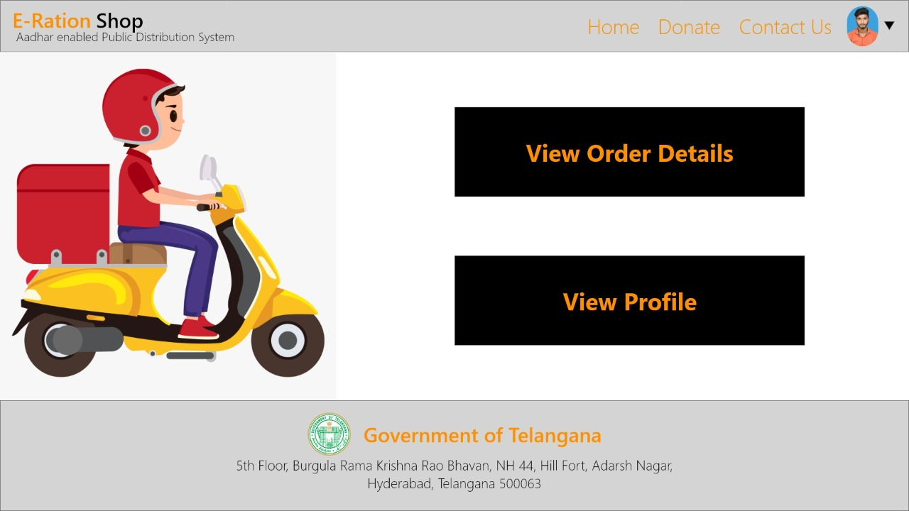

Fig 2.1

2.2 Order Details
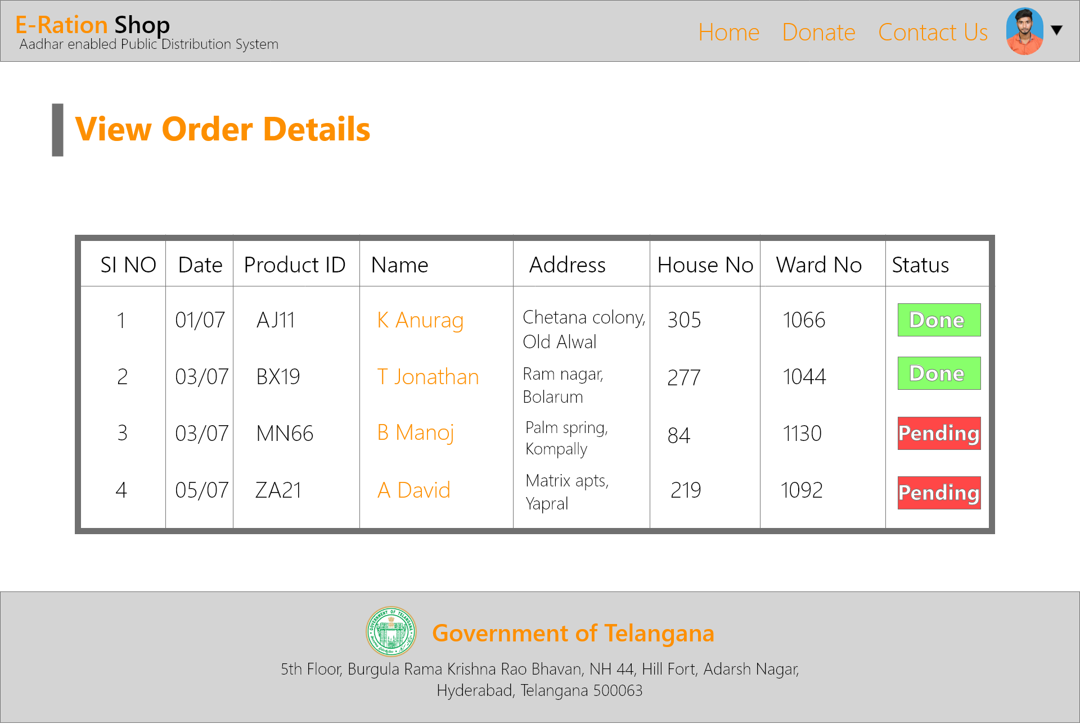

Fig 2.2

2.3 Delivery agent profile
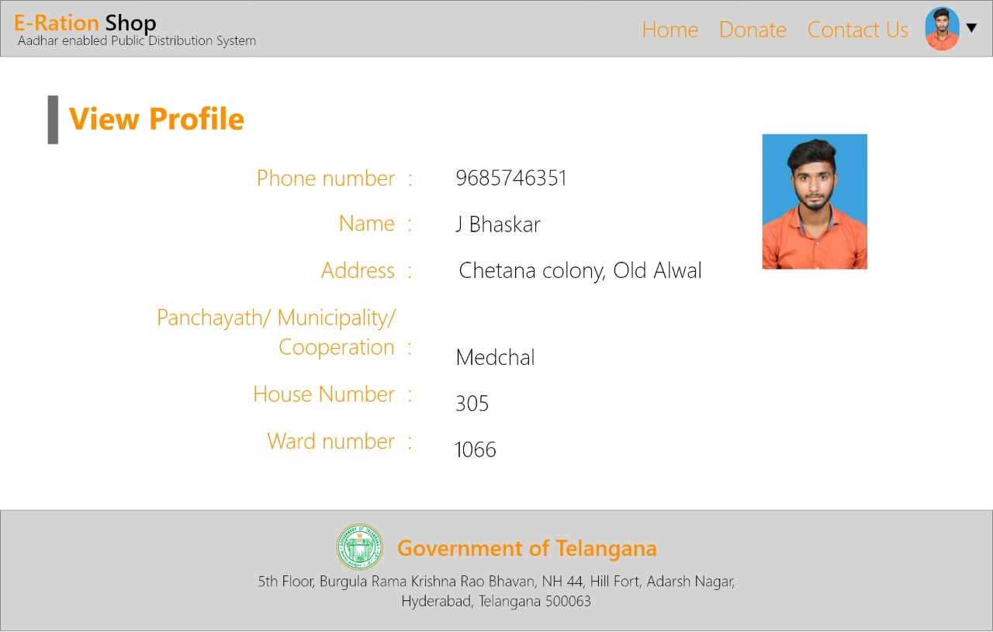

Fig 2.3

3. Government Administrator

3.1 Admin page
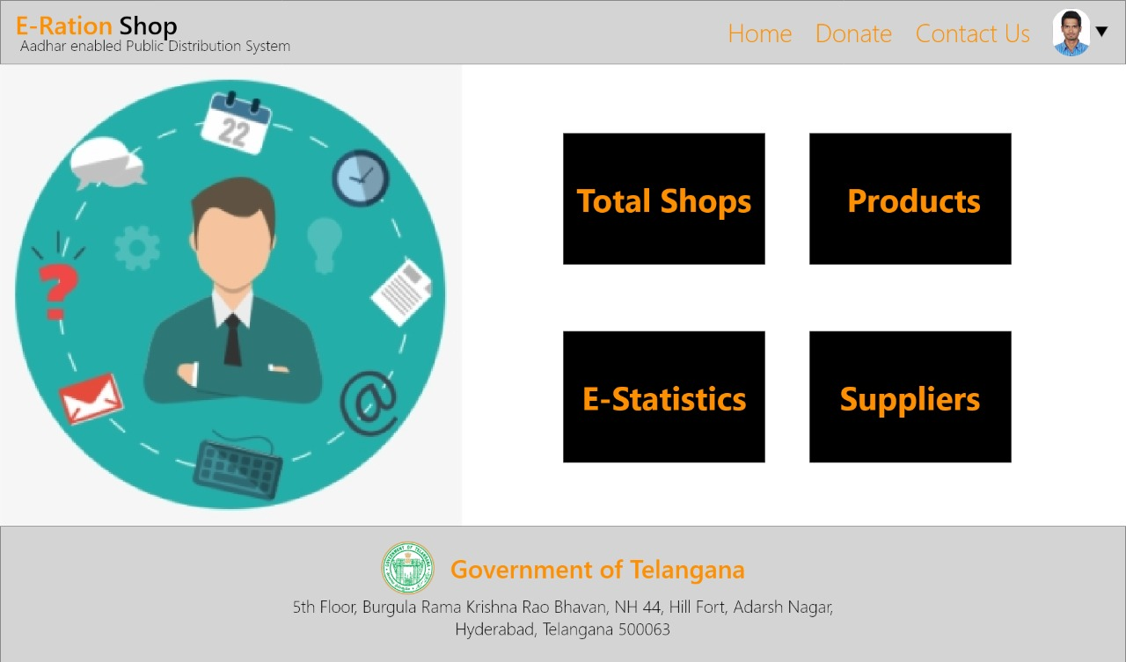

Fig 3.1

3.2 Ration shop details
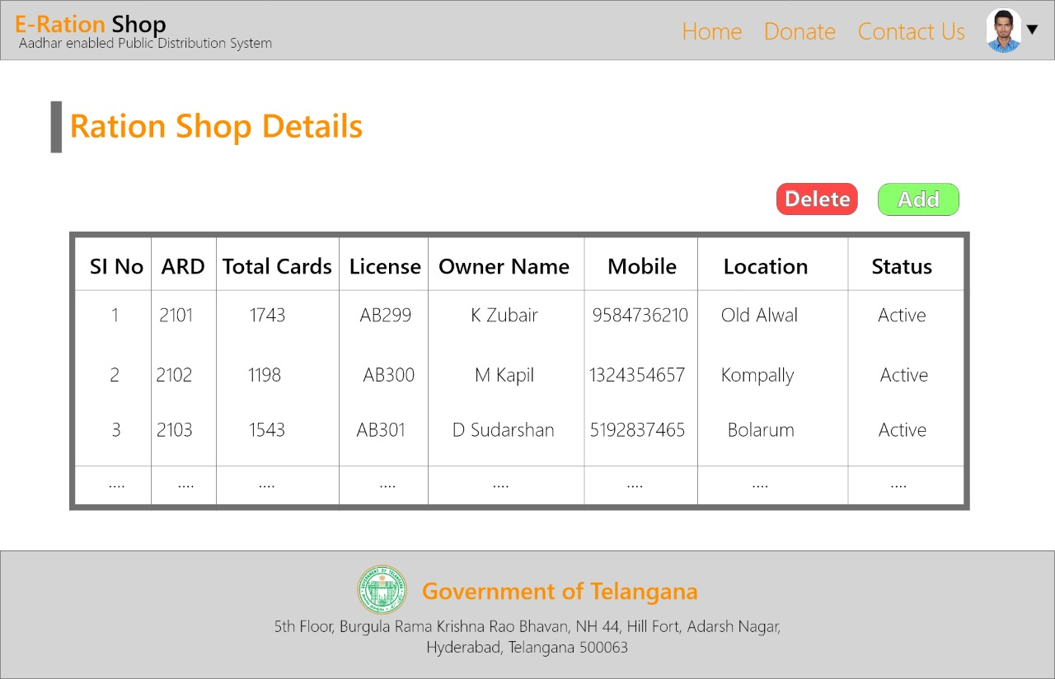

Fig 3.2

3.3 Supplier details
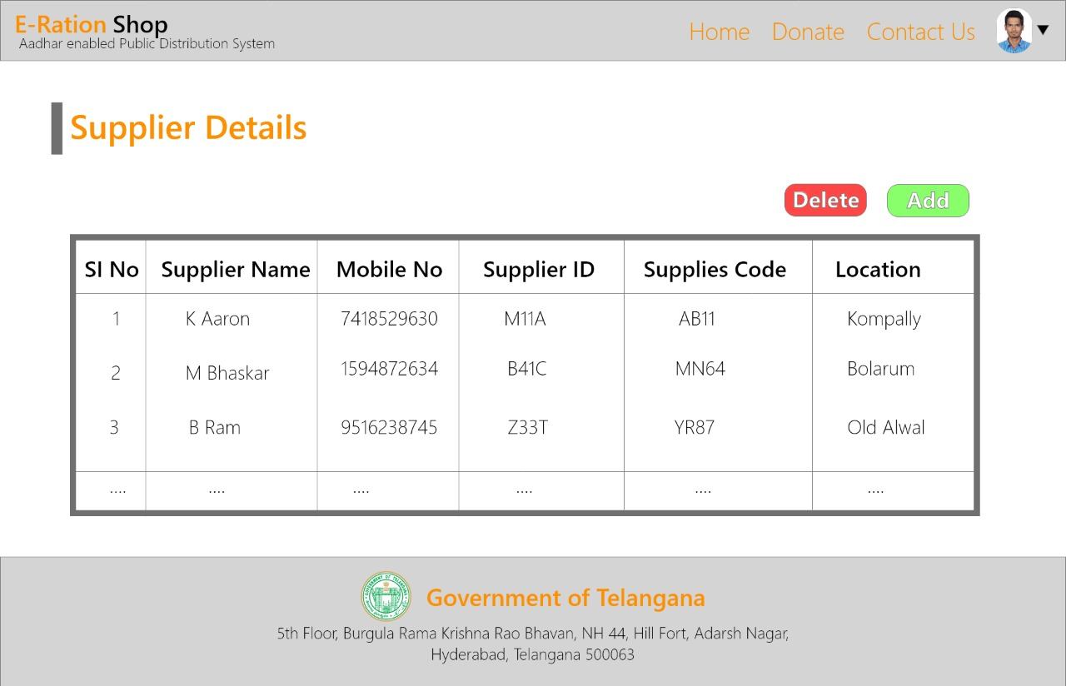

Fig 3.3

3.4 Customer details
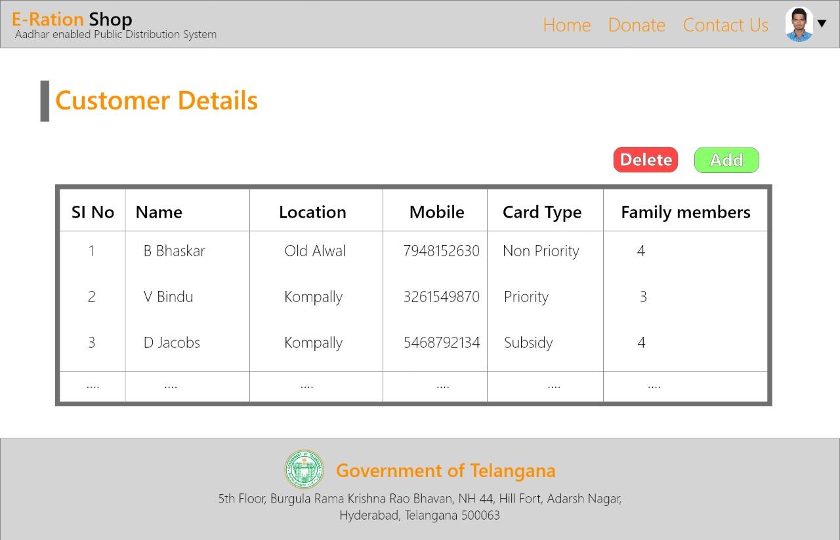

Fig 3.4

3.5 Product report
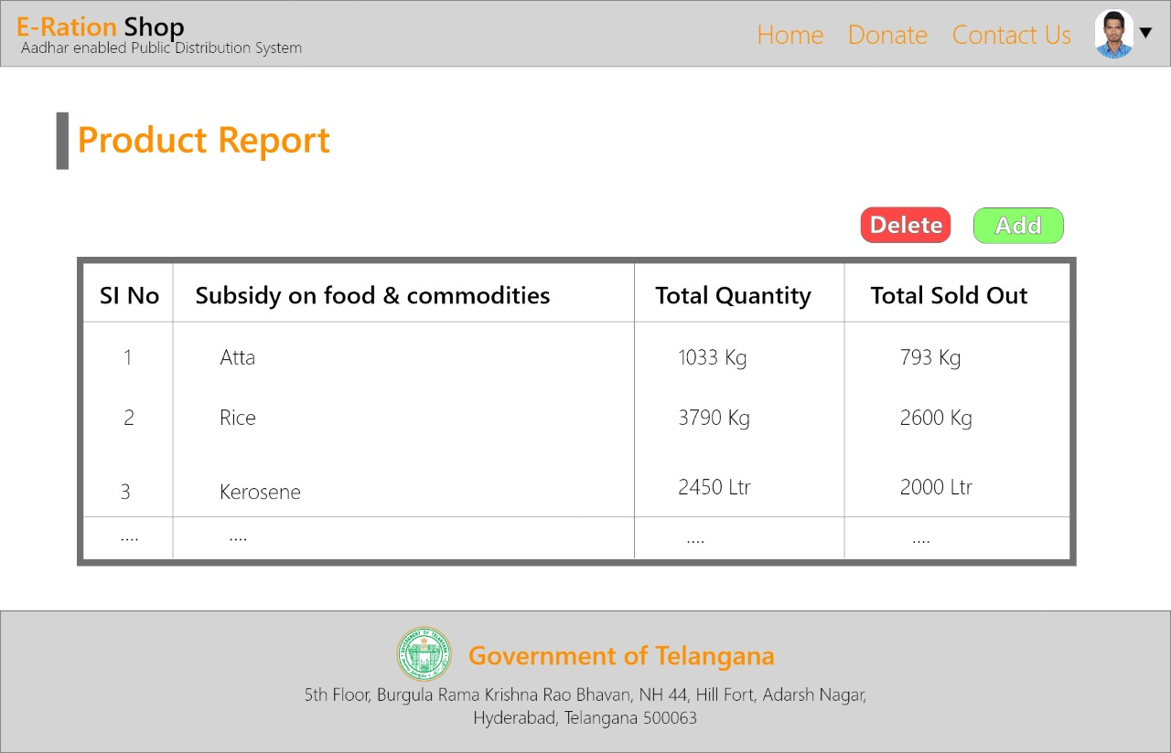

Fig 3.5

3.6 E-Statistics
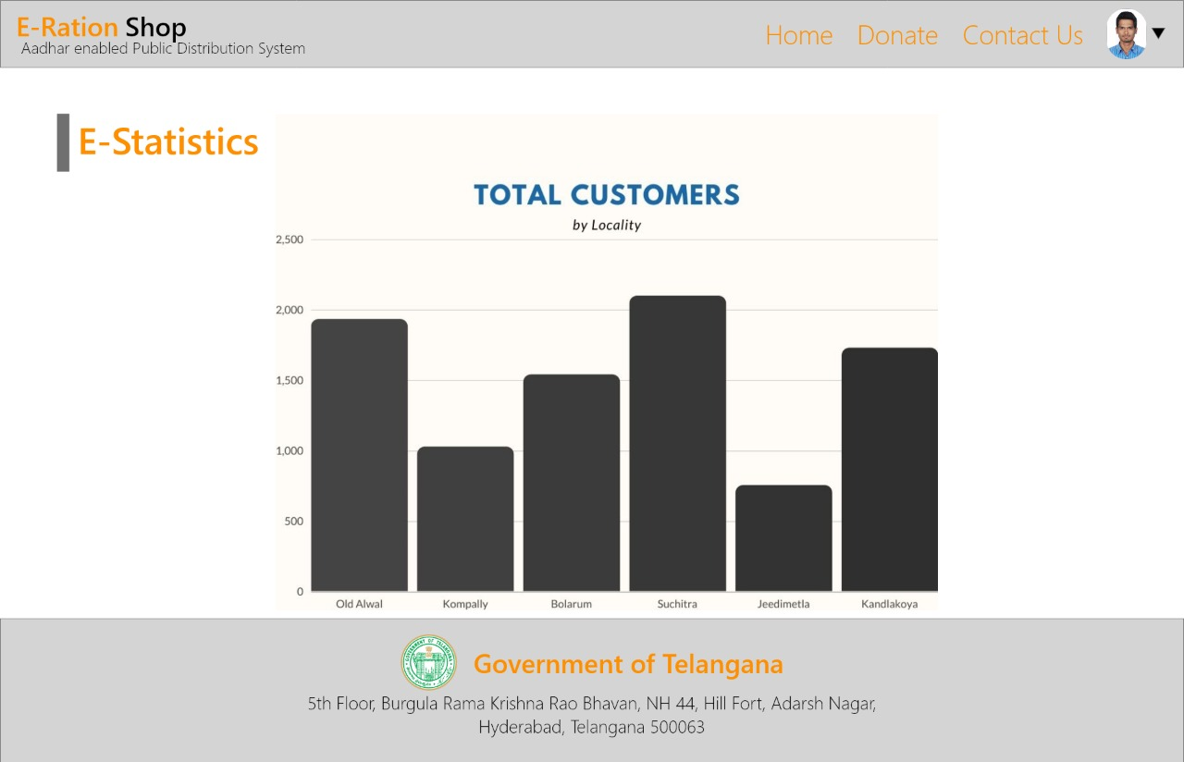
Fig 3.6

4. Ration Supplier

4.1 Supplier page
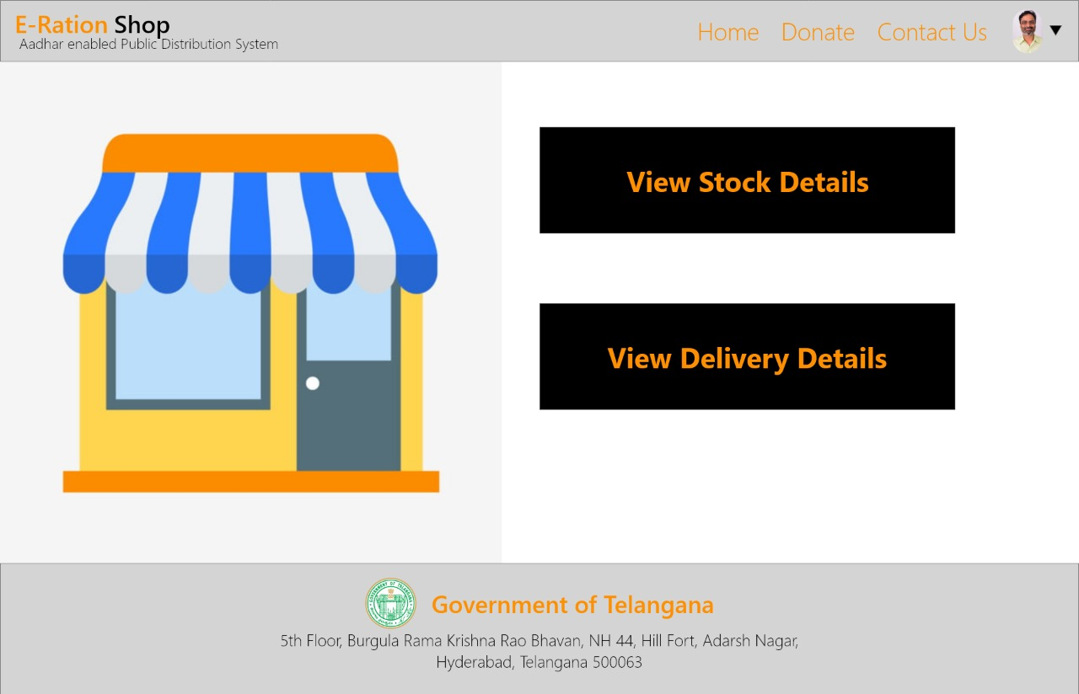

Fig 4.1

4.2 Stock details
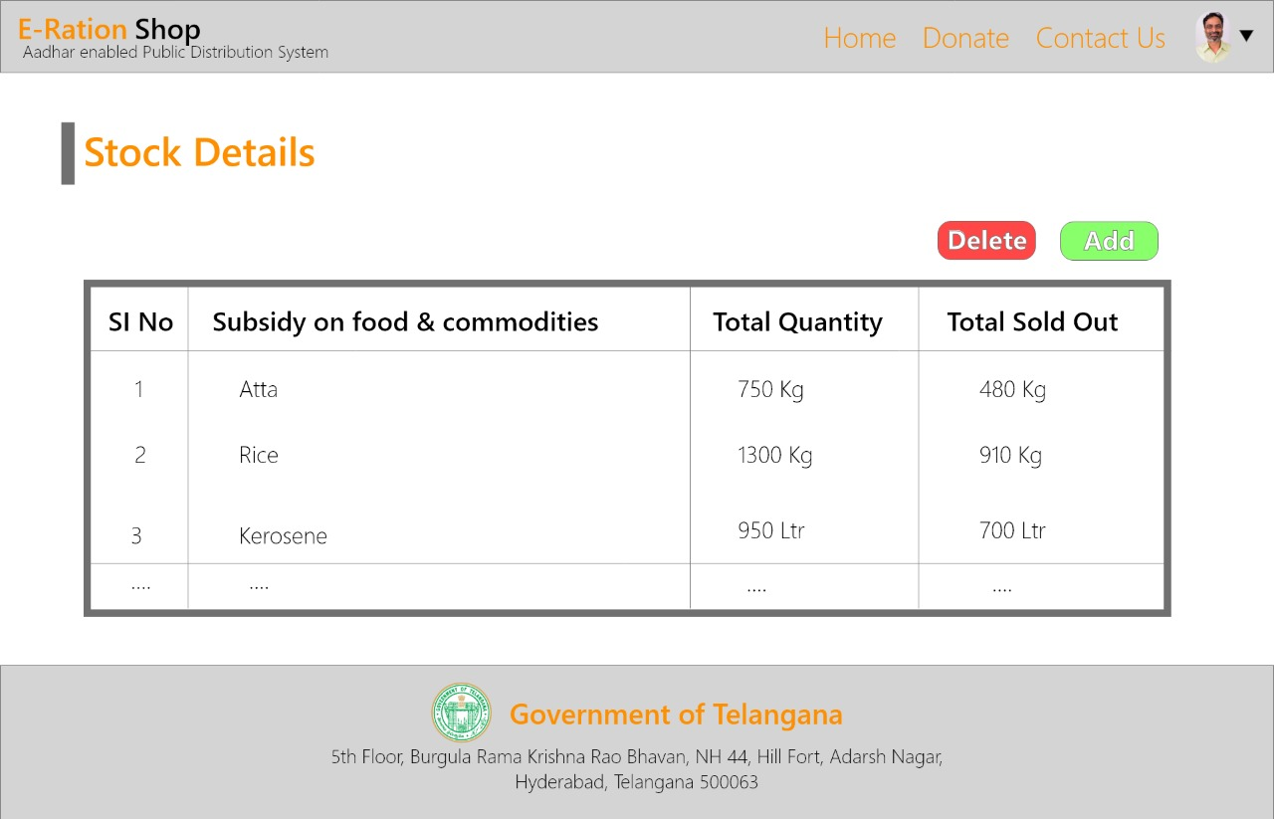

Fig 4.2

4.3 Delivery details
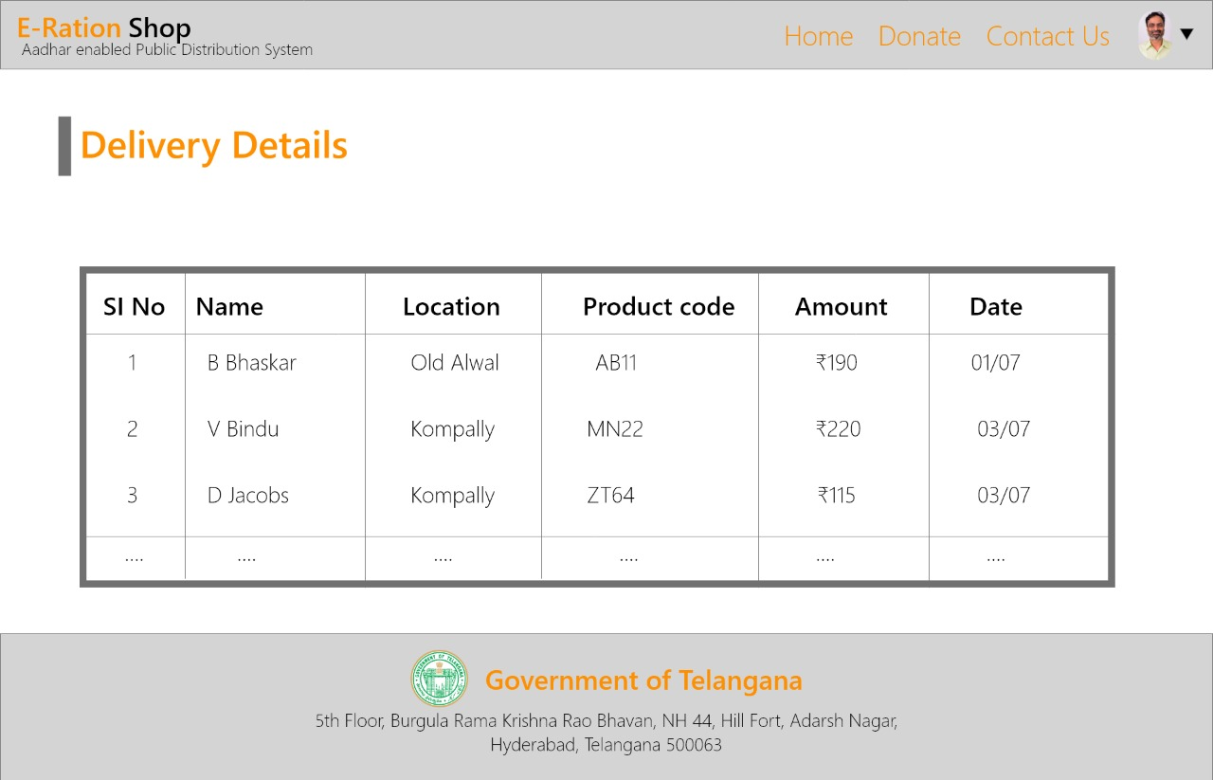

Fig 4.3

CONCLUSION

Here conclude, this ration shop management system is developed for the ease and usability of the user in purchasing monthly rations via an online platform. This online system would allow multiple transactions to take place and to be stored in a database which is then viewed by the administrator. Implementing this system almost entirely removes the need for the physical strain on the body by going to ration shops as well as reduces strain on the dealers by implementing computer-based calculations and stock keeping.

REFERENCES

- Rachel Andrew. (2019) Using CSS effectively [online]. Available at: https://www.smashingmagazine.com/2019/01/using-css-effectively/ [Accessed 5th July 2020]

- Mahammad Shafi Rajasahe. (2022) An Automation Tool for Fair Price Shop[online]. Available at: https://www.researchgate.net/publication/358739017 [Accessed 14th June 2022]

- Sribala Vadlapatla. (2021) OTP-based ration system [online]. Available at: https://timesofindia.indiatimes.com/city/hyderabad/otp-based-ration-system/ [Accessed 7th July 2020]

- Chloe West. (2020) Design a website [online]. Available at: https://visme.co/blog/how-to-design-a-website/ [Accessed 23rd May 2020]

